**DBS Lab 7**

# **JOINS**

1. Write a query to display the employee name, department number, dept name and dept location for all the employees.

Output:

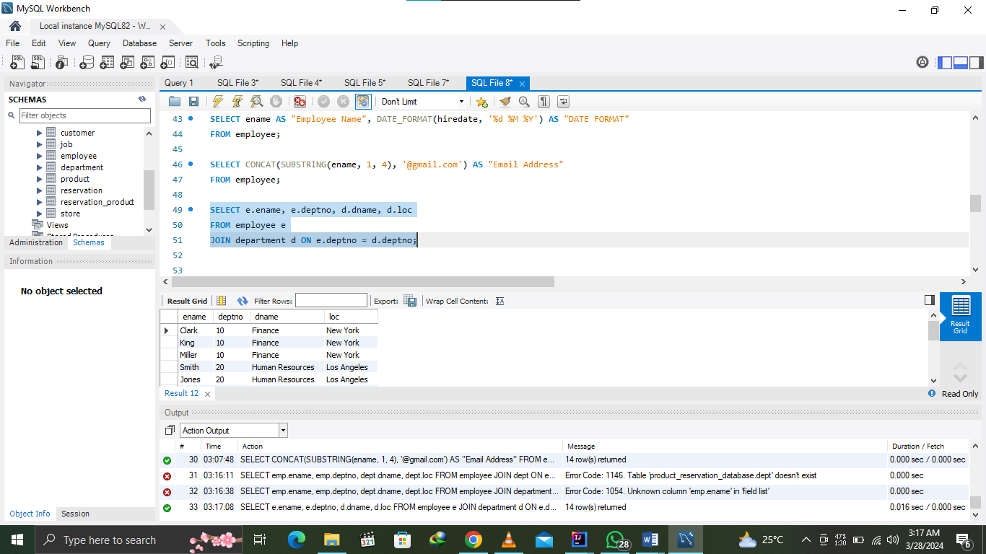

1. Create a unique listing of all jobs that are in dept 30. Include the location of department in the output.

Output: 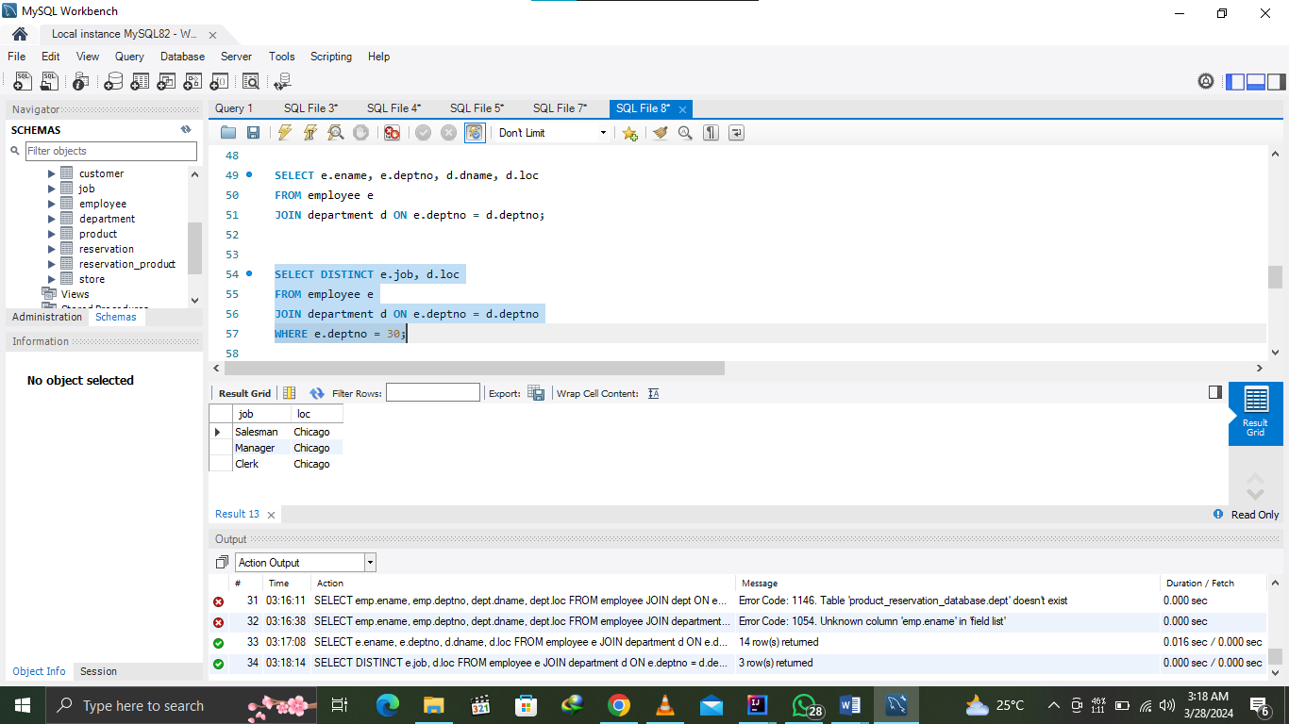

1. Write a query to display the employee name, emp sal, department name, dept location of all employees who earn a commission.

Output: 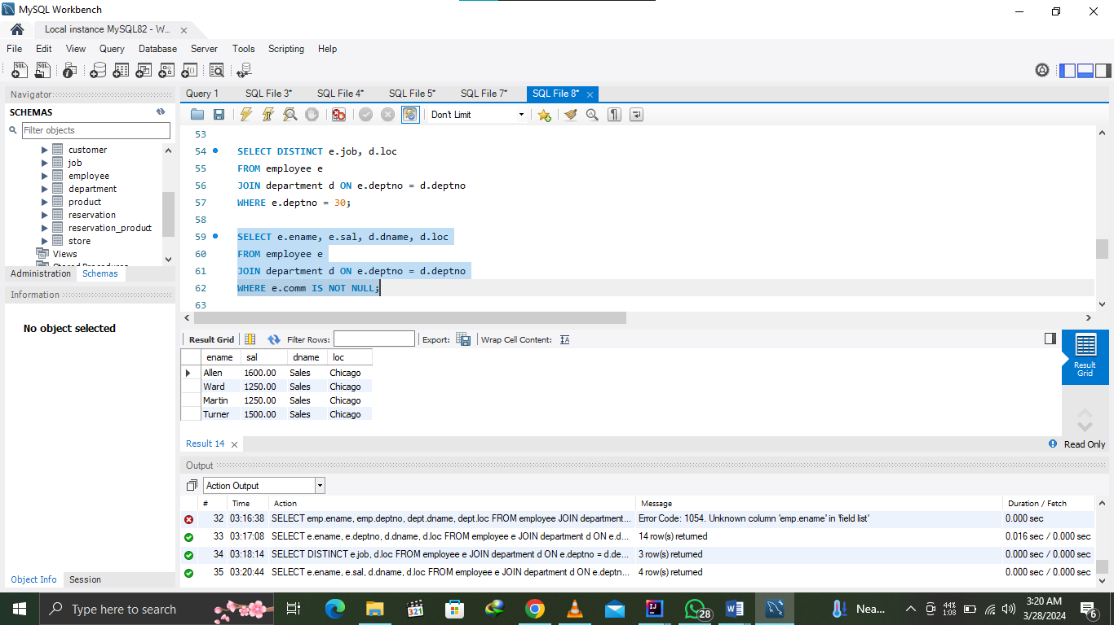

1. Write a query that lists empno, ename, mgr id and dname from emp and dept table.

Output: 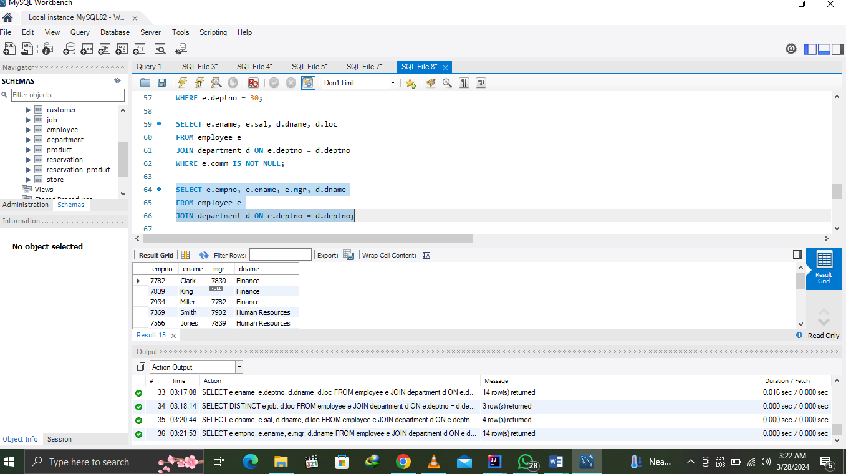

1. Write a query that returns all the employees, their related information and dept name and even those department where no employee is working.

Output: 